**REPORT TO THE TRUST BOARD**

**Date** October 2021

|  |  |
| --- | --- |
| **Title** | **Staffing Paper – 6 monthly report** |
| **Sponsoring Director** | Name: Lisa Salter  Title: Chief Nurse |
| **Author (s)** | Name: Nicola Martin  Title: Deputy Chief Nurse |
| **Previously considered by:** | Senior nursing team |
| **Executive Summary** The purpose of this paper is to provide assurance regarding nurse staffing and other clinical staffing at The Walton Centre. This is the first full review that has been undertaken since covid, it is undertaken 6-monthly as per NICE guidance, with the last papers being presented in a different format due to COVID 19. The review is undertaken to ensure that all stakeholders including patients, families, staff and the Trust Board recognise and understand the risks and assurances associated with current staffing levels and the actions required ensuring quality care is delivered in a safe and cost effective manner.  This paper identifies that staffing is safe within The Walton Centre and Quality Committee and Trust Board are requested to receive a further report in 6 months, or sooner should staffing alter. | |
| **Related Trust Strategic Objectives** | Deliver best practice care  Invest, be financially strong  Lead research, education and innovation  Recognised as excellent in all we do |
| **Risks associated with this paper** | As contained within the paper |
| **Related Assurance Framework entries** | Related to BAF risk on national nurse shortages and ability to maintain safe staffing levels. Risk Number 0035  COVID 19 Risk Number 0001 |
| **Equality Impact Assessment completed** | N/A |
| **Are there any associated legal implications / regulatory requirements?** | * Yes – NHSE / NHSI and CQC requirements and regulations |
| **Action required by the Board** | * To acknowledge the report * Receive a further report in 6 months |

1. **Executive Summary**

The purpose of this paper is to provide assurance regarding nurse staffing and other clinical staff groups at The Walton Centre. All NHS providers are required to undertake a minimum annual review of nursing staffing levels (NQB, National Quality Board *Safe, sustainable and productive staffing* an improvement resource for adult inpatient wards in acute hospitals) (Quote NQB doc). This review is undertaken 6-monthly as per NICE guidance, with the last paper being presented in May 2021. The review is undertaken to ensure that all stakeholders including patients, families, staff and the Trust Board recognise and understand the risks and assurances associated with current nurse staffing levels and the actions required to ensure quality care is delivered in a safe and cost effective manner. This paper identifies that staffing is safe within The Walton Centre and Quality Committee and Trust Board are requested to receive a further report in 6 months.

1. **Introduction and Background**

In January 2018, the National Quality Board (NQB)[1] released updated guidance in respect of adult in-patient areas, defined as wards that provide overnight care for adult patients in acute hospitals. For the purpose of this review, it includes the following areas;

Wards: Cairns, Dott, Sherrington, Chavasse, CRU, Lipton, ITU, Theatres and OPD

(NB Note that Caton Ward is currently closed due to heating work)

The functionality of each ward here at The Walton Centre can be found in appendix one.



Table 1; NQB’s expectations for safe, sustainable and productive staffing

**Expectation 1 - Right staff**

The NQB recommends that there is an annual strategic staffing review, with evidence that is developed using a triangulated approach (accredited tools, professional judgement and a comparison with peers). This should be followed with a comprehensive staffing report to the Board after 6 months.

Here at The Walton Centre the Safer Nursing Care Tool used is the Shelford model. This was developed to help NHS hospital staff measure patient acuity to inform evidence based decision making on staffing and workforce. This acuity review is undertaken twice a year in line with NQB recommendations.

Table 2 shows the outcomes of the acuity review taken over a 21 day period for the month of October 2021. It is important to note that wards are currently not functioning at their speciality level and colour coded pathways remain in place to support the safe management and risks of covid. Occupancy is also low therefore the acuity review demonstrates that all areas are currently safely staffed but a further review in 6 month’s time is required when hopefully wards will be back to their specific speciality. The tool is clear that changes should not be made as a consequence of only one or two sets of data as occupancy and acuity can have seasonal differences.

|  |  |  |  |  |
| --- | --- | --- | --- | --- |
| **Ward** | **Funded establishment (wte)** | **Acuity tool outcome**  **(wte)** | **Professional judgement tool** | **Additional information** |
| CRU | 56.21 | 49.36 | 58.7 | 4 empty beds |
| Lipton | 29.37 | 30.3 | 29.6 | 1empty bed |
| Cairns | 40.57 | 28.13 | 37.7 | 3-12 empty beds and day case patients |
| Caton | Closed at time of review | Closed at time of review | Closed at time of review | Closed at time of review |
| Sherrington | 40.57 | 31.50 | 37.7 | Empty beds range from 4-7 |
| Chavasse | 56.95 | 31.13 | 59.8 | Empty beds range from 4-10 |
| Dott | 39.99 | 22.7 | 37.7 | Empty beds and day case patients |

Table 2: Outcome of acuity review October 2021

**Process for determining staffing levels**

1. **Professional judgement**

The judgement of senior experienced nurses should also be a critical factor in determining staffing levels. Judgement takes into consideration;

* Cohort nursing requirement
* Ward leadership
* Ward layout and environment
* Additional specific training requirements
* Support of carers/patients
* Escort duties
* Multi-professional working
* Shift patterns

Each division is working to ensure safe staffing for every area on a shift by shift basis. The Matrons and Ward Managers work closely to ensure effective and efficient strategic monitoring and management of staffing with the principle aim to promote patient safety and optimise patient and staff experience.

A ward still remains closed in the Trust due to pipework and staff from this area have been redeployed to other wards to support safe staffing, increase in sickness levels and to reduce shift requests to NHSP where and when possible.

1. **Registered Nurse to Patient ratio**

The Registered Nurse (RN) to patient ratio is based on the number of RNs on duty to care for patients during a shift. NICE and RCN guidelines recommend no more than 8 patients per RN on a day shift (early or late). This is based on NICE evidence highlighting that there is increased risk of harm to patients when RNs care for more than 8 patients at any one time. The ward manager should have supervisory capacity. All ward managers at The Walton Centre are supernumerary but do cover sickness and staffing gaps as and when required. There is no specific guidance regarding night duty, albeit the RCN guidance on safe nurse staffing levels in the UK 2021 states no more than 10 patients to 1 RN.

Staffing data, Care Hours per Patient Day (CHPPD) and actual and planned staffing is analysed monthly. This information is uploaded onto the national database (Unify), to the WCFT website for public access and reported to Trust Board; this reporting has continued throughout the COVID 19 pandemic.

The Trust continues to have a daily safety huddle chaired by the Chief Nurse and staffing is discussed for the organisation at this meeting. Following this a bed meeting is held every day at 10 am chaired by a Divisional Nurse Director, whereby nurse staffing levels are discussed and dynamic risk assessments completed, staff are moved, where required, to support patient and staff safety.

**Staffing situation since the presentation of the May 2021 nurse staffing review**

* New Deputy Chief Nurse is now in post
* New Tissue viability nurse for the trust has been appointed to and commences post in November 2021.
* The Infection Prevention and Control team is now fully recruited to.
* The original Trust (PEF) continues to act up into an 8A role to oversee International Recruitment, nursing education and competencies.
* Neurology Matron has moved into the service improvement team and a new Matron is due to start early November
* Divisional Nurse Director for Neurosurgery is currently off and so the Matron for neurosurgery is currently acting into the role and a specialist nurse acting into the Matron role.

Table 3; Compliance against key recommendations

|  |  |  |  |
| --- | --- | --- | --- |
| **Recommendation** | **Assessment** | **Compliant** | **Variation** |
| RN to Patient ratios not exceeding 1:8 day shifts | All adult in-patient areas achieve a maximum ratio of 1 RN to 8 patients on day shifts | √ | Some areas have benefitted from higher RN to patient ratios due to ward closure and reduction in bed occupancy (please see occupancy levels below) |
| Evidenced based Tool | The Organisation has Safer Nursing Care Tool which analyses acuity and dependency and review was undertaken for 21 days from 1st October | √ | Whilst this has been undertaken, it is noted that there is a lack of validity and reliability due to the current ward case-mix changes during covid-19 pandemic |
| Headroom/uplift | Headroom/uplift is calculated at 21% - compliant | √ | In line with guidance |
| Skill Mix | All areas re-reviewed in 2021 | √ | A ward closed due to pipework resulting in redeployment of staff to various wards |
| Professional judgement | All areas have been reviewed in 2021 and are also reviewed monthly by the Divisional Nurse Directors and the Informatics team | √ | All areas current staffing levels deemed safe |

1. **Headroom / Uplift**

Headroom relates to the percentage of non-effective working days that are included in each establishment (for annual leave, training, sickness etc). Uplift is the required increased staffing to cover the non-effective days to ensure the shifts are covered and patient care delivery is safe.

The NQB provides indicative figures based on annual leave, sickness, study leave, parenting leave and ‘other’. The uplift of establishments at The Walton Centre is set at 21% RN and 19% HCA to ensure that staffing is appropriate and financially viable. The uplift whilst lower than the national average, accounts for the higher dependency of newly qualified staff who do not have the additional leave (week) that staff who have worked for the NHS longer are entitled to, training requirements of each staff groups, as well as other leave arrangements.

Actions have been taken to improve fill rate of shifts with NHSP and the nurse bank has successfully been implemented across the Trust. This has been very positive and from September 2018 when work was commenced, we have continually seen a reduction in agency and an increase in bank which was the pattern we required and anticipated. The Trust is also in the process of implementing Health Roster; this is an electronic system which gives clear transparency of shifts covered and shifts out to NHSP. This calculates staff hours also ensuring staff don’t accumulate hours owed to them or to the Trust. These rosters will be built 6 weeks in advance with a sign off process in place and shifts going out in advance to NHSP which in turn will improve the fill rate.

1. **Skill Mix**

This is the ratio of RNs to unregistered staff, such as healthcare assistants (HCA). Traditionally, the nationally recommended benchmark has been 60% RNs, whilst the Royal College of Nursing (RCN) has advocated a benchmark of 65%/35% split. More recent NICE guidance has focussed more specifically on the RN to patient ratio, as skill mix can be skewed by higher (appropriately) numbers of unregistered staff whilst the ratio of RN to patients can actually still be appropriate and compliant.

The current RN/HCA skill mix at The Walton Centre is:

|  |  |  |  |  |
| --- | --- | --- | --- | --- |
| **Wards** | **Number of beds** | **Establishment Early** | **Late** | **Night** |
| Cairns | 26 | Ward manager supernumerary  4 RNs 3 HCAs | 4 RNs 3 HCAs | 3 RNs and 3 HCAs |
| Caton | 25 | Ward manager supernumerary  4 RNs 3 HCAs | 4 RNs 3 HCAs | 3 RNs and 3 HCAs |
| Dott | 27 | Ward manager supernumerary  4 RNs 3 HCAs | 4 RNs 3 HCAs | 3 RNs and 3 HCAs |
| Sherrington | 25 | Ward manager supernumerary  4 RNs 3 HCAs | 4 RNs 3 HCAs | 3 RNs and 3 HCAs |
| Chavasse | 29 | Ward manager supernumerary  6 RNs 6 HCAs | 5 RNs 6 HCAs | 4 RNs and 5 HCAs |
| CRU | 30 | Ward manager supernumerary  5 RNs 6 HCAs | 4 RNs 6 HCAs | 4 RNs 6 HCAs |
| Lipton | 10 | Ward manager supernumerary | 3RNs 3HCAs | 2RNs 2HCAs |

Table 4: Current skill mix establishment

At The Walton Centre there are more HCAs on duty than RNs due to the nature of the patient’s conditions. HCAs will support the enhanced needs of the patient particularly when they require one to one support or require rehabilitation.

1. **Safety outcome indicators**

NICE originally advocated specific indicators that could be incorporated to determine safe staffing levels. These indicators were noted to be specifically affected by the presence (and hence absence) of registered nursing staff. These indicators include;

* Falls
* Medication errors
* Infection rates
* Pressure ulcers
* Omissions in care
* Missed or delayed observations
* Unplanned admissions to ITU

**Walton Accreditation Tool**

The Walton CARES (Communicate, Assess, Respect, Experience and Safety) Review assesses performance based on the Trust core standards. The framework is designed around 15 standards with each one subdivided into four categories including, patient experience, and observations, documentation and staff experience. Compliance against these standards is measured in various ways to gather a full picture of the ward and care delivered.

During COVID the CARES reviews were paused but have since restarted. It was agreed a condensed version of the review would be undertaken to ensure face to face contact with patients and staff for periods of time were kept to a minimum due to the current climate.

The following areas have had the shortened version of the CARES Review undertaken and results are pending:

* Theatre Department
* Caton Ward
* Chavasse Ward
* Radiology

Following a review, the manager of the above area will meet with a review panel who consider the findings and the additional portfolio of information they provide and inform the manager of the overall rating which is Bronze, Silver, Gold or Platinum.

The above areas have not awarded as yet until presentations at Panel is completed.

The overall outcome of the review will determine the frequency of forthcoming reviews as per below:

Bronze Review again in 3 months

Silver Review again in 9 months

Gold Review again in 12 months

Platinum (achieved Gold rating for 3 consecutive reviews) Review again in 12 months

The plan is to ensure all clinical areas across the Trust have a CARES review undertaken by year end.

**Harm data per 1000 bed days**

The overall falls and pressure ulcers remain within normal variation and outcomes per 1000 beds days were favourable compared to national data at last reporting pre covid-19.

For individual ward data please see appendix Two

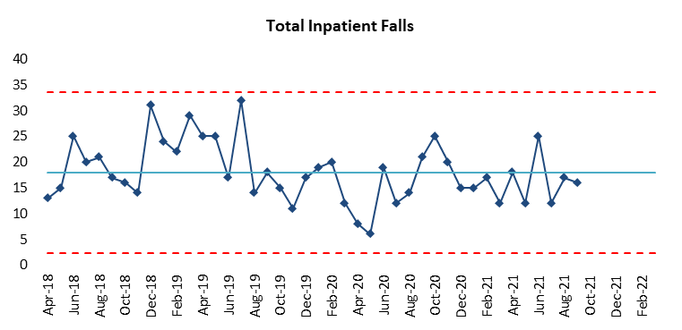

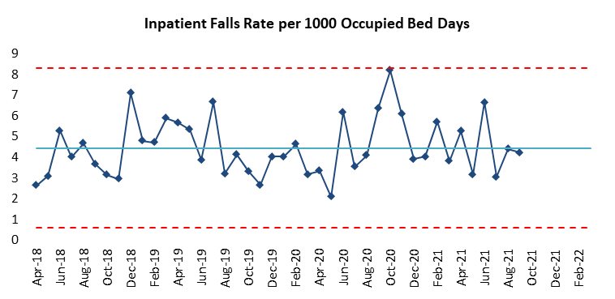

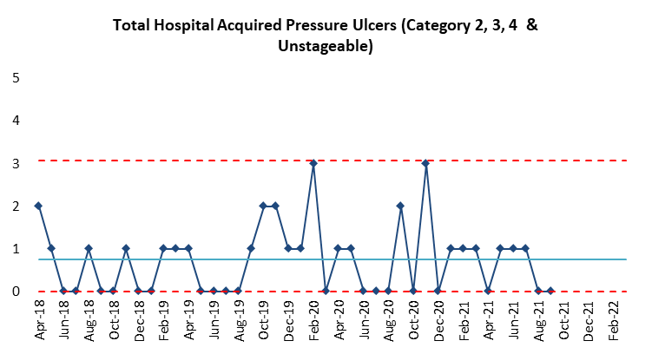

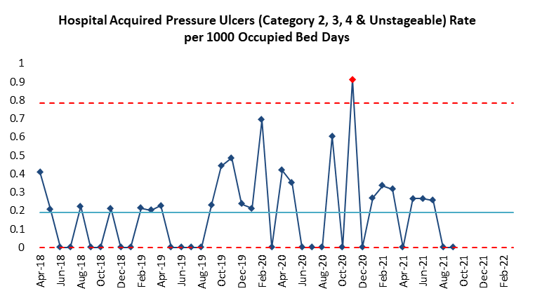

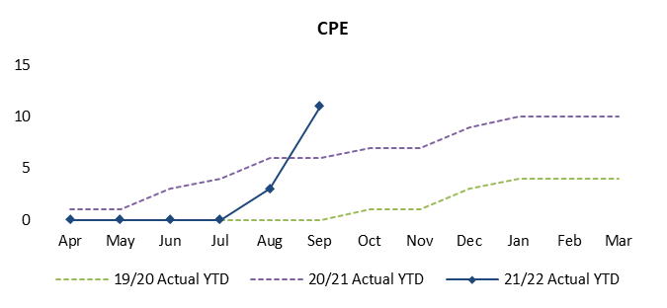

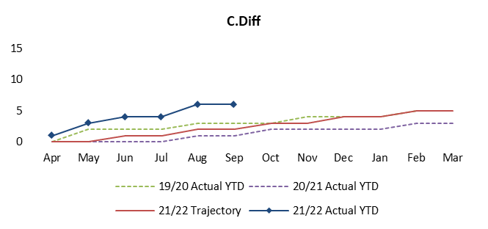

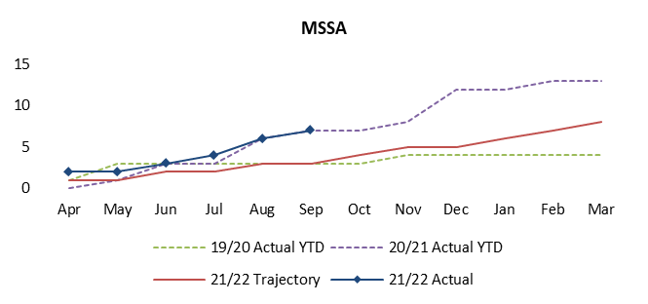

The senior nursing team are in the process of trialling perfect ward; this is an electronic solution to nursing audits in order to undertake additional quality audits/reviews of activities and environments at a local level. This local drive to incrementally improve care will support significant changes in patient quality outcomes and experience.

**Red Flags**

In accordance with NICE (2018) guidance for Safe Staffing, clinical establishments should be reviewed alongside Nursing and Midwifery red flags. Red flag events are classified as:

* An unplanned omission in providing medications
* A delay in providing pain relief
* An incidence where vital signs have not been assessed or recorded
* Missed intentional (3Cs)
* A shortfall in 25% of the required Registered Nursing or Midwifery hours for a shift
* Less than two Registered Nurses or Midwives available on a shift.

Red flags for inpatient services are reported by clinical staff via the datix system.

|  |  |
| --- | --- |
| **Red Flags April 2021-October 2021Red Flags** | **Totals** |
| TWC |
| An unplanned omission in providing medications | 0 |
| A delay in providing pain relief | 1 in sept  Dott ward |
| An incidence where vital signs have not been assessed or recorded | 0 |
| Missed 3Cs | 1 in sept cairns ward |
| A shortfall in 25% of the required Registered Nursing or Midwifery hours for a shift | 0 |
| Less than two Registered Nurses or Midwives available on a shift. | 0 |

Both red flags were investigated by the Divisional Nurse Director with an outcome of no harm to the patients.

1. **Staffing data & Training and Education**

* Appraisal, retention, vacancy, sickness, maternity leave
* Mandatory training, clinical training

The Trust currently has 26 RNs and 2 healthcare assistants on maternity leave. In order to mitigate this, the Trust recruits 1wte for every 2 nurses who are on maternity leave. In addition, bank staff are sought if there are insufficient nurses recruited / acuity is high.

|  |  |  |  |  |  |  |  |  |  |
| --- | --- | --- | --- | --- | --- | --- | --- | --- | --- |
|  | **Statutory training** | | | **Mandatory training** | | | **PDR** | | |
|  | **July 21** | **Aug 21** | **Sept 21** | **July 21** | **Aug 21** | **Sept 21** | **July 21** | **Aug 21** | **Sept 21** |
| **Corporate** | 94% | 92% | 94% | 90% | 88% | 90% | 83% | 81% | 79% |
| **Neurology** | 94% | 94% | 94% | 93% | 93% | 91% | 83% | 83% | 80% |
| **Surgery** | 91% | 90% | 91% | 87% | 87% | 86% | 76% | 71% | 70% |

Table 6: Percentage of staff completed training and PDR

* **Triangulation of Quality metrics and staff and patient reported outcomes**

Evidence contained demonstrates that there has been an overall deterioration across infection prevention and control. Clearly it is a challenge to isolate this to a specific cause and the covid-19 pandemic obviously remains an over-riding factor. The Nursing leadership team has held IPC awareness sessions in September 2021 to share lessons learnt and a detailed action place is in place for CPE, C diff and MSSA. All HCAI infections are in the process of review also and lessons learnt will be shared.

1. **Process measures**

* Hand hygiene, documentation standards

A process is now in place to monitor hand hygiene submissions on a weekly basis. The IPC team provide the Deputy Chief Nurse and Divisional Nurse Directors with areas submission data, any shortfalls are escalated and assurance provided this is completed.

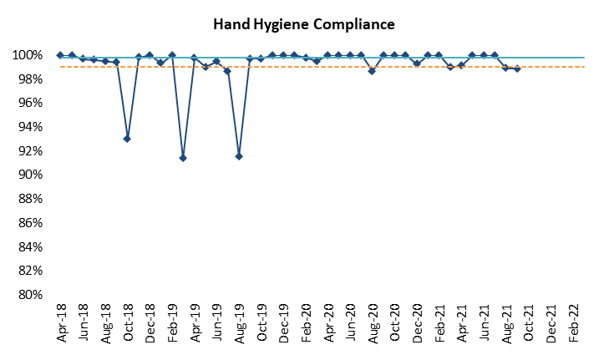

1. **Comparison with peers**

Peer comparisons can act as a platform for further enquiry, although caution should be exercised. The model hospital dashboard can also be used as a reference point.

Usually the report would cover benchmark with other trusts to provide assurance however no benchmarking exercise has been undertaken since COVID 19 and due to the redesigned ward pathways during the pandemic the numbers would not reflect the current ratios and the way we are working to ensure patients are allocated safely. The next paper provided to the board will include a benchmark with peers.

**Expectation 2 – Right Skills**

The NQB states that clinical leaders should be supported at a local level to deliver high quality, efficient services with a staffing resource that reflects a multi professional team approach. Specifically, the following is recommended;

* Skill mix – this should be reviewed ensuring compliance with professional judgment and evidence reviews and may take into account presence of additional roles
* Training – all members of the clinical team must be appropriately trained to be effective in their role
* Leadership – it is important to ring-fence time in the roster for managerial work and for the supervision of staff. The NQB (2018) references the Mid-Staffordshire inquiry report as follows;

*“Ward nurse managers should operate in a supervisory capacity, and not be office bound or expected to double up, except in emergencies as part of the nursing provision on the ward. They should know about the care plans relating to every patient on his or her ward. They should make themselves visible to patients and staff alike, and be available to discuss concerns with all, including relatives. Critically, they should work alongside staff as a role model and mentor, developing clinical competencies and leadership skills with the team.”*

As noted earlier in the report, all ward managers at The Walton Centre are supernumerary but at times do work clinically when the ward is at reduced establishments.

Recruitment and retention – strategies should be in place

**International Nurse Recruitment**

With the national challenges in nurse staffing, the Trust have joined the Cheshire and Merseyside collaborative to participate in International Recruitment. A business case was developed and approved by the executive team for 40 international nurses and a fixed term post for a band 6 pastoral care nurse to support the international nurses.

The Walton Centre has recruited 39 / 40 nurses with final interview date 26/10/21 for last candidate. 12 of the nurses have commenced in the Trust across wards, ITU and Jefferson day ward. 9 of these nurses are awaiting their pin number from the Nursing & Midwifery Council (NMC) which may take up to 10 weeks to arrive. The other 3 nurses are taking resit exams on 28th October.

All other nurses are due to arrive in the trust from November through to February and should be fully trained and practicing on their areas no later than February 2022.

**Age Profile of staff**

|  |  |  |
| --- | --- | --- |
| **Age Band** | **Headcount** | **WTE** |
| 21-25 | 25 | 25.00 |
| 26-30 | 68 | 65.73 |
| 31-35 | 65 | 60.48 |
| 36-40 | 43 | 40.01 |
| 41-45 | 51 | 48.94 |
| 46-50 | 41 | 38.30 |
| 51-55 | 43 | 39.85 |
| 56-60 | 44 | 33.33 |
| 61-65 | 16 | 11.05 |
| 66-70 | 3 | 1.88 |
| **Grand Total** | **399** | **364.58** |

Table 5: current age profile of nursing staff

It is clear from the data above that work needs to continue to support recruitment and retention at The Walton Centre, as the Trust has 106 nurses above the age of 50. The Walton Centre should continue to engage with the international recruitment process as funding allows and continue with the work to recruit nurse’s externally ensuring engagement continues with student nurses also to support recruitment.

**Expectation 3 – Right place, right time**

The NQB recommends that in addition to the delivery of high-quality care, Boards should ensure improvements in productivity. This will include effective management and rostering of staff, with clear escalation policies if concerns arise.

Recommendations to support this include;

* Productive working (LEAN, Productive ward)
* E-rostering
* Flexible working
* Staff deployment
* Minimising agency staffing
* Measure and improve – a local quality dashboard for safe and sustainable staffing that includes ward-level data should be in place

During the ongoing clinical challenges and changes in direct response to the covid-19 pandemic, the current bed base pathways at The Walton Centre has developed inconsistencies in nurse staffing levels and also has been subject to various alterations in specialty location as a response to covid requirements.

**Right place, right time**

The Walton Centre is in the process of launching a SMART E-Rostering system to support the inpatient nursing workforce. E-Rostering enables organisations to provide further assurance on their effective use of resources by targeting key performance indicators (KPIs) for roster publications, annual leave, sickness levels, study requests, changes to rosters after sign off and if rosters are signed off on time. E-Rostering KPI reports have been compiled and cascaded across the areas that are currently utilising e roster.

Safe care is in the implementation phase, this will provide daily data regarding acuity and dependency on each area to support decision making when risk assessing to move nurses from other areas to support safe staffing.

**Temporary staffing**

Overall bank spend has not significantly increased due to Covid-19 during this current time period, however, assurance around booking and deployment has been detected as lacking reliability and additional measures need to be considered. Historically ITU and Theatres have not utilised NHSP, this culture has now progressed and both areas are engaged with the use of NHSP staff. All outstanding shifts for ITU are requested until january 2022 in order to try and pro actively increase the fill rate for this area. Other organisations are reviewing their NHSP rates and introducing incentives which is making it difficult to improve fill rates therfore the divisions have requested block bookings from agencies to support shortfall until the vacancy gaps of these areas improve.

Graphs can be found in Appendix Three for our RN and HCA hours required for September 2021.

**Enhanced care rates (Specialling)**

Inpatients that require enhanced care through direct 1:1, bay tagging or cohorting are managed at ward level and any additional staff required to support is requested via NHSP.

This is requested as a HCA on NHSP therefore data isn’t currently available to provide detail regarding the number of 1:1 shifts requested via NHSP. The Deputy Chief Nurse is currently working with NHSP to separate this from establishment requests in order to see the level of 1:1 shifts requested.

CRU does have cameras that support the management of patient safety and reduces the numbers of 1:1s required across the unit; however staff have also been identified to monitor the screens and coordinate where care is required.

**Vacancies**

The table below displays the current Registered Nurse vacancies

|  |  |  |  |
| --- | --- | --- | --- |
| **Row Labels** | **Budgeted WTE** | **M6 Actual WTE** | **Vacancies/Over Establishment** |
| Cairns Ward | 21.94 | 17.59 | 4.35 |
| Caton Ward | 21.44 | 15.71 | 5.73 |
| Chavasse Ward | 26.66 | 20.24 | 6.42 |
| Complex Rehab Unit | 24.53 | 19.15 | 5.38 |
| Dott Ward | 20.53 | 15.79 | 4.74 |
| Horsley Ward | 106.08 | 96.38 | 9.7 |
| Lipton Ward | 15.83 | 16.88 | +1.05 |
| Outpatients Department | 4.48 | 4 | 0.48 |
| Sherrington Ward | 21.24 | 21.24 | 0 |
| Theatres | 67.55 | 65.16 | 2.39 |
| **Grand Total** | **330.28** | **270.9** | **59.38** |

Table 6:Current RN vacancies not including staff in pipeline

|  |  |  |  |
| --- | --- | --- | --- |
| **Row Labels** | **Sum of Budget WTE** | **Sum of Actual WTE** | **Vacancies/Over Establishment** |
| Cairns Ward | 18.75 | 24.59 | -5.84 |
| Caton Ward | 17.75 | 26.24 | -8.49 |
| Chavasse Ward | 31.29 | 35.62 | -4.33 |
| Complex Rehab Unit | 32.68 | 36.79 | -4.11 |
| Dott Ward | 18.05 | 25.77 | -7.72 |
| Horsley Ward | 16.44 | 17.41 | -0.97 |
| Lipton Ward | 15.41 | 15.66 | -0.25 |
| Nursing Pool | 8.51 | 2.56 | 5.95 |
| Outpatients Department | 16.67 | 16.42 | 0.25 |
| Sherrington Ward | 19.66 |  | 19.66 |
| Theatres | 21.03 | 19.69 | 1.34 |
| **Grand Total** | **216.24** | **220.75** | **-4.51** |

Table 7: Current HCA establishment, the Trust is currently over recruited for HCAs

There are also currently 8.76 nurse associates in RN Budget and 2 trainee nurse associates in place.

**Sickness**

Staff sickness plays a huge role in shortfalls on the majority of wards and results in temporary shifts being requested or staff redeployment occurring to maintain safety. This has a cumulative effect on the redeploying ward as pressures to maintain patient safety is increased. Sickness is managed by the Ward Manager, with Divisional Nurse Director support, Human Resources monitoring and when required, input from Occupational Health. Sickness is managed actively, fairly and consistently balancing the needs of staff with the efficient running of a safe, clean and personal service. The trust does have a ward closed for pipework which is supporting safe staffing of other areas following temporary staff redeployment. The target for sickness is 5%.

|  |  |  |  |  |  |  |  |  |  |
| --- | --- | --- | --- | --- | --- | --- | --- | --- | --- |
|  | **Jan-21** | **Feb-21** | **Mar-21** | **Apr-21** | **May-21** | **Jun-21** | **Jul-21** | **Aug-21** | **Sep-21** |
| **Absence FTE %** | 11.30% | 8.87% | 6.25% | 8.04% | 8.13% | 8.15% | 9.96% | 10.15% | 9.50% |

|  |  |  |  |  |  |  |  |
| --- | --- | --- | --- | --- | --- | --- | --- |
|  | **Feb-21** | **Mar-21** | **Apr-21** | **May-21** | **Jun-21** | **Jul-21** | **Aug-21** |
| 160 Cairns Ward (1602100) | 7.46% | 5.75% | 7.68% | 7.18% | 6.97% | 11.94% | 14.15% |
| 160 Caton Ward (1602130) | 13.80% | 4.20% | 1.88% | 3.67% | 5.35% | 9.02% | 9.79% |
| 160 Dott Ward (1602110) | 6.74% | 7.20% | 10.57% | 9.09% | 4.25% | 4.72% | 9.59% |
| 160 Horsley Ward (1602000) | 7.11% | 5.92% | 8.28% | 9.06% | 9.63% | 12.01% | 8.58% |
| 160 Jefferson Ward (1602090) | 15.27% | 8.52% | 7.58% | 3.98% | 6.80% | 1.32% | 0.00% |
| 160 Sherrington Ward (1602120) | 12.08% | 9.56% | 26.15% | 24.33% | 29.03% | 19.67% | 0.00% |

**Retention**

NHS Improvement (2019) advises the retention of staff is a key issue for the NHS and it is critical that organisations focus on securing skilled and sustainable workforce for the future. In addressing the challenges of workforce supply, organisations must focus not only on recruitment but also should ensure new and existing staff are supported and encouraged to remain in the NHS. All staff is encouraged to undertake exit interviews to aid managers in identifying themes and learning related to why staff are leaving. Current themes from exit interviews are staff are leaving for promotion, the trust has lost a number of nurses to the community setting also. People group meetings are now set up and this is one aspect of work the group will be focusing on.

|  |  |  |  |  |  |  |  |  |  |
| --- | --- | --- | --- | --- | --- | --- | --- | --- | --- |
|  | **Jan-21** | **Feb-21** | **Mar-21** | **Apr-21** | **May-21** | **Jun-21** | **Jul-21** | **Aug-21** | **Sep-21** |
| **Turnover Rate (FTE)** | 1.00% | 0.60% | 0.73% | 0.00% | 1.98% | 1.70% | 2.30% | 0.92% | 2.86% |

Further work is required to promote and ensure staff participates in exit interviews so their views can be captured and considered. The Trust has recruited our own practice education facilitator primarily to support and co-ordinate pre-registration students however they can further support the transition from student nurse to registered nurse and ensure staff are prepared and well equipped. The senior nursing team has requested to be made aware of any nurses planning to leave so a conversation can be held to determine if any actions can be taken to retain the nurse.

**Occupancy**

The below chart and graphs show the occupancy levels for all inpatient areas, ITU and the rehabilitation wards. To support renewal of heating and pipework the Trust has had a ward closed since January 2021.

|  |  |  |  |  |
| --- | --- | --- | --- | --- |
| **Month** | **General &**  **Acute beds** | **ITU** | **CRU** | **Lipton** |
| Apr-21 | 62.59% | 58.50% | 77.11% | 98.89% |
| May-21 | 72.22% | 56.94% | 67.85% | 99.64% |
| Jun-21 | 75.77% | 54.33% | 73.89% | 82.22% |
| Jul-21 | 75.95% | 61.45% | 71.08% | 84.59% |
| Aug-21 | 73.99% | 60.80% | 68.49% | 97.85% |

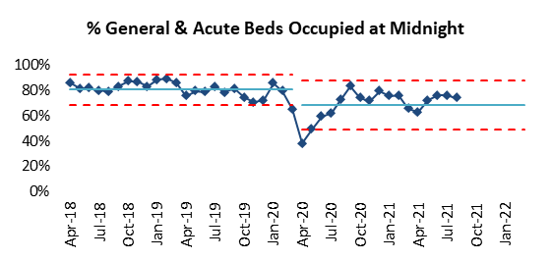

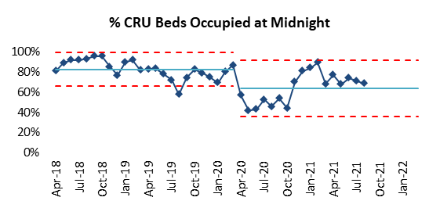

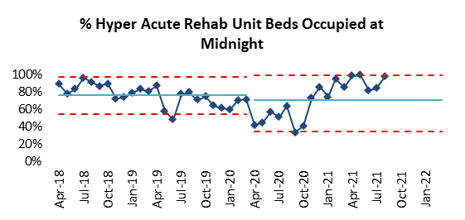

**Theatres**

Theatre utilisation continues to increase in line with NHSE covid guidance; we have started to increase normal theatre activity. We agreed that staff would don and doff PPE when moving from dirty to clean areas instead, reinforcing the importance of hand washing and gelling of hands. The exception to this was confirmed COVID 19 positive patients would still use clean and dirty runners.

Several adjustments were required to ensure activity recommenced, different routes were taken for patients with COVID 19 or suspected infection with designated green and amber forward wait areas and recovery areas. Red patients were recovered post operatively in the theatre instead of recovery as they were in the highest risk category.

Theatres have seen an unprecedented demand on staffing due to high levels of sickness across the nursing and ODP staffing, short and long term with some relating to serious illness. Block booking of agency staff have been requested and have recruited x2 ODPs to date. Daily meetings have been put in place across the division to review daily activity versus nurse staffing and staff utilised from other areas and the SMART team to support ITU and theatres.

**ITU**

ITU continues at times to provide mutual aid to other organisations when staffing allows. ITU is experiencing sickness (short and long term), maternity leave and vacancies. All shifts are out to NHSP and a request has been sent to agency for block bookings to support this. Occupancy levels remain low.

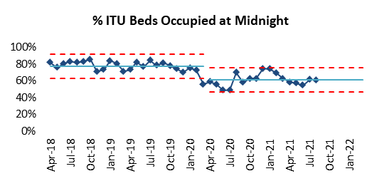

**Radiology**

Against a continuing backdrop of a national shortage of Consultant Radiologists and Radiographers, WCFT currently have no Consultant Radiologist vacancies, following the appointment of 2 Clinical fellows to Consultant posts in 2020. The ability for staff to report from home has increased reporting volumes and has removed the requirement for reporting waiting list initiatives. There is an increased pressure on reporting with the extension of the Thrombectomy service to 24/ 7. The impact of this will be identified at 2021 job planning.

The Radiographer staffing group, remains relatively stable, but has been under pressure throughout 2021 due to members of the team on Maternity leave and 1 member of the team on a long term career break. Recruitment to vacant posts has so far been successful, although non Neuro trained radiographers take approximately 18 months to train fully in the department. All members of the Radiographic team have had HCPC registration confirmed until 2022.

The department continues to place a high level of importance on the investment of training, together with in house professional development. A further two radiographers are undertaking post graduate courses in CT and MRI advanced Imaging. Deputy Radiology Manager is undertaking a Master’s programme in Management, as part of the Trust apprenticeship scheme. Radiology Digital Systems Manager is undertaking a post graduate module in project management to support developments in Radiological information system and Picture archiving and communication system.

In addition, the Department has Advanced Practice Radiographers in Fluoroscopy and Doppler imaging, to support different ways of working.

There has also been an appointment to 1 x Apprenticeship trainee Assistant Practitioner and one further post will be offered in March 2022. There was agreement for 2 in plan, but unfortunately one had to drop out at beginning of course, so the department are 1 short of the plan.  The aim is to train the two AP’s to undertake screening in theatre, releasing 2 x band 6 posts in the future.

**Therapies**

The Walton Centre Therapies service consists of 5 AHP disciplines hold valid HCPC registration: Occupational Therapy, Physiotherapy, Speech & Language therapy, Dietetics and Orthoptists. Together these teams provide specialist therapy intervention to acute wards, ITU, rehabilitation units CRU & Lipton Hyper acute, community rehab , out patients, Pain management ,Trauma and Spinal services.

Throughout the pandemic the Therapies service has responded to changing clinical needs with all staff participating in redeployment of roles and working in new ways to support the Trust by providing mutual aid. Therapies worked with LUFT to transfer the Acute stroke service in house and utilised specialist neuro therapy skills to ensure the best care possible for stroke patients. During the first wave of the pandemic all therapies staff worked together to support nursing teams in all areas. Face to face outpatient care was paused during the first lockdown. However, the teams worked quickly and innovatively to restore patient care via telephone and video contact. All therapy teams have successfully adapted to agile working practices where possible and are actively supporting the Trust in resuming inpatient and outpatient services.

The biggest challenge in the past year has been in continuing to provide safe and effective patient care during periods of higher than normal staff absence related to Covid 19 and staff self-isolating a home. However all staff where possible have adapted well to agile working such as supporting administration teams from home. The support of Walton IT team has been key to this in working efficiently to provide equipment and remote access for staff.

The Therapies staffing across the board remains relatively stable, but has been under significant pressure throughout 2020 / 21 due to higher levels of Maternity leave with senior staff. Back fill with internal secondment’s plus external appointments has resulted in a 25 % of therapies staffing on fixed term contracts and significant cost pressures.

Recruitment to vacant posts has mostly been successful, although there remains a national shortage of Speech and language therapists.

**Undergraduate education:**

All registered therapy staff are accredited to provide pre-registration clinical education placements across the Centre. During 2021 the service has joined forces with NW HEE to support the Cheshire & Merseyside strategy for AHP education. In 2020 all undergraduate student placements where curtailed and AHPs resulting in a significantly higher demand for clinical placements. This comes at a time when all AHP undergrad programs have been expanded as part of the future workforce plan. This has required all providers to create innovative approaches to education and Therapies have started delivering new hybrid models of education such as distance learning / virtual clinical placement and 1: 3 student placements. All therapists’ continue to be actively involved in providing internal and external training and education .CPD remains an essential component of good quality care and this has been enhanced during 2020 to ensure all staff are able to maintain skills and HCPC registration.

The main body of the service remains at a consistent level and continues to attract skilled staff from across the country. Notably the Principal Dietitian has recently been appointed Head of School for Nutrition and Dietetics at Wrexham University and will continue to work at Walton on a clinical trial. Succession planning is a constant theme within a specialist Trust and leadership opportunities beyond band 6 and 7 for AHPs continues to be limited.

Two physiotherapists have transferred in to Advanced Clinical practice roles within Critical care and the first physiotherapy apprenticeship is underway and one occupational therapy assistant is being supported to complete the part time degree pathway in Occupational therapy. The service has committed to supporting a minimum of two apprenticeships per year from 2021.

**Neurophysiology**

Clinical Physiologist and Consultant Neurophysiologist staffing has been stable during 2021, in comparison to the previous year where, due to pressures from maternity leave, Clinical Physiologist staffing was a challenge. Following a skill mix review, the service is in the now process of recruiting across the Band 6/7 level to provide support across video telemetry and theatre monitoring. Both degree apprentices graduated with first class honours and both were recruited into the team in September 2021, a fabulous example of return on investment! Two further degree apprentices have just started their three year training programme and it was encouraging to be inundated with high caliber applicants.

The service continues to have an excellent national reputation for training Clinical Physiologists and actively supports undergraduate, post-graduate and doctorate training programmes, both in terms of academic teaching, exam marking and work based assessments. In addition, two Specialist Registrars have been training alongside the Consultant Neurophysiologists. The service continues to embrace extended roles for Band 7 Clinical Physiologists in terms of independent approval of clinical reports.

All Clinical Physiologists are on the voluntary Registration Council for Clinical Physiologists (RCCP).

The EEG video telemetry service recommenced as part of the Trust’s recovery and restoration plans, though the focus to undertake as many tests in the home setting (where clinically appropriate) will continue as we are now utilising technology that allows high quality video recordings without the need for hospital admission. However, as part for of the epilepsy surgery programme there will still remain a cohort of patients for whom hospital admission is essential.

1. **Conclusion & Recommendations**

The attached review demonstrates a) current compliance against NQB b) current triangulation of a spectrum of outcomes that are evidenced to be directly linked to presence and absence of, registered nurse and health care assistant staffing levels.

It continues to be a challenging period for all staff. There has been one concern raised to CQC from Chavasse ward, following the concern raised the Chief Nurse, Deputy Chief Nurse and the Divisional Nurse Director met with staff on the ward to discuss concerns and actions taken to address. The chief nurse has worked a night shift to spend time with staff and the divisional nurse director has continued to meet with staff on a regular basis. There have been no further concerns raised. There are high levels of flexibility and adaptability has been seen during this period. Due to the ward changes staffing and patient acuity requirements have been reviewed by the Trust’s senior nursing team, on a daily basis Trust wide staffing and acuity is considered to ensure all patients can be cared for safely. All shifts have been reported as safe.

Trust Board is asked to:

* Receive assurance that staffing across all areas is considered safe
* Receive the next 6-monthly staffing report in May 2022, unless further changes require reporting.

**Appendix One**

**Clinical Areas**

Pre covid all wards had a specific specialty as described below; the senior management teams are currently working with the infection prevention and control team to aim to get back to this position as soon as possible. Currently the Trust is still operating via Red, amber and green pathways.

**Cairns:** is a 26 bedded acute Neurosurgical ward that predominantly accommodates neuro-oncology patients and patients that have hydrocephalus. The ward is split in to 4 bays and 3 side rooms.

Due to the nature of the sub specialities on this ward a lot of staff time is spent with patients and families who have received life altering news offering advice and support. Some patients suffer cognition issues due to their condition. This ward is currently operating as a green pathway ward.

**Caton:** is a 25 bedded acute Neurosurgical ward that predominantly accommodates patient that has had routine spinal surgery and those that have suffered spinal trauma. The ward is split in to 4 bays and 3 side rooms.

The sub speciality of the ward means that the patient flow is faster than it may be on other ward areas.  On occasions a patient that is admitted with spinal fractures sometimes requires additional staff and equipment to maintain their safety and prevent further damage. This ward is currently closed.

**Dott Ward:** is a 27 bedded acute Neurosurgical ward that predominantly accommodates patients that have suffered trauma through vascular event i.e. Subarachnoid haemorrhage. The ward is split in to 4 bays and 4 side rooms.

Due to the nature of the sub speciality on the ward some patients suffer cognition issues meaning that these patients can require additional staff supervision and or be violent and aggressive. This cohort of patients is more likely to have spent periods of time in critical care and can have tracheostomies requiring additional observations and input from SMART. This ward is currently operating as a green pathway ward.

**Sherrington Ward:** is a 25 bedded acute Neurosurgical ward that predominantly accommodates patient that have suffered cranial trauma from head injury and patients that are having routine spinal surgery.

Due to the nature of cranial trauma some patients may suffer cognition issues meaning that these patients can require additional staff supervision and or be violent and aggressive. These cohorts of patients are more likely to have spent periods of time in critical care and can have a tracheostomies requiring additional observations and input from SMART. Having the routine spinal patients also means a quicker patient flow for this ward. In light of the variable number of patients that suffer cranial trauma, Sherrington ward is more likely than the other areas to have a mixture of the other sub speciality patients which again can mean varying levels of patient acuity and dependency. This ward is currently operating as an Amber pathway ward.

**Chavasse Ward: -** This is a 29 bedded acute Neurology, Pain and long term conditions ward. It also has 4 dedicated Video-telemetry beds which are used for diagnostic and pre surgery purposes. It is made up of 4 bays (each comprising of 4 beds), and 13 individual rooms each with their own en-suite toilet and shower. There is also an assisted bath on the ward. This ward is currently operating as an Amber pathway ward.

Chavasse ward also has a Day room for patients and due to its ‘horse track’ layout, a central outside courtyard which patients can access.

**Complex Rehabilitation Unit (CRU):-** This is a 30 bedded Unit commissioned by the Cheshire and Merseyside Rehabilitation Network (CMRN). It comprises of 20 Level 1 and 10 Level 2 complex rehabilitation beds all based in individual en-suite rooms. There is also an independent living flat inside the department for patients aiming towards discharge.

Due to its size and layout the Unit is spilt into two sides (green and purple) each accommodating 15 beds. There is a communal sitting and dining area which aims to help the social and psychological aspect of a patient’s rehabilitation. There is also a private outside area for patients and relatives to use to socialise but in addition it can be used by therapists to assess patients. There is a dedicated therapies gym and smaller activity rooms to be used for smaller group/ individual work such as the kitchen.

**Lipton Ward: -** This is a 10 bedded Hyper-Acute Rehabilitation unit commissioned by the CMRN. These patients are extremely dependent, many needing tracheostomy tubes to protect their airway when they first arrive, having suffered severe trauma. There are 2 bays (1 being 4 bedded and the other 3) and 3 individual rooms with en-suite shower. The ward also has an assisted bath for those patients who are more stable. There is also a gym adjacent to the ward for patients to access with the therapists.

**Outpatients Department (OPD):-** This department is split over the 2 sites, main OPD has 22 clinic rooms, with a further 11 clinic rooms based in Sid Watkins Building offering a 6 day per week service.

**Theatres: -** Theatres have the capacity to run 8 fully functioning operating lists covering multiple surgical specialties, these range from Vascular, Oncology, Spinal, Functional, Trauma and Pain. The Trust earlier in 2017 expanded the theatre environment from the provision of 6 operating theatres to 8 and has the facility to provide Intraoperative MRI’s during surgical intervention.

**Jefferson Ward: -** Jefferson ward is located next to the Theatre complex to allow for patients to be transferred for their surgery in a seamless manner. The team work alongside the Theatre surgical and recovery teams to ensure patient safety and experience is maximised. Patient care is supported in this area by Advanced Practitioners who provide hands on care and education to patients and staff alike.

**Appendix Two**

|  |  |  |  |  |  |
| --- | --- | --- | --- | --- | --- |
| **Total Patient Falls** | |  |  |  |  |
|  | **18/19** | **19/20** | **20/21** | **21/22** | **Total** |
| Cairns | 37 | 24 | 36 | 22 | **119** |
| Caton | 34 | 24 | 29 | 6 | **93** |
| Chavasse | 45 | 36 | 39 | 16 | **136** |
| CRU | 45 | 32 | 25 | 18 | **120** |
| Dott | 29 | 31 | 42 | 12 | **114** |
| Horsley | 2 | 4 | 3 | 2 | **11** |
| Lipton | 11 | 2 | 8 | 4 | **25** |
| Sherrington | 42 | 64 | 8 | 21 | **135** |
| **Total** | **245** | **217** | **190** | **101** |  |
| **Total Moderate & Above Harm Inpatient Falls** | | | | |  |
|  | **18/19** | **19/20** | **20/21** | **21/22** | **Total** |
| Cairns | 3 | 0 | 0 | 1 | **4** |
| Caton | 0 | 0 | 0 | 0 | **0** |
| Chavasse | 0 | 0 | 0 | 0 | **0** |
| CRU | 0 | 0 | 0 | 0 | **0** |
| Dott | 1 | 0 | 0 | 0 | **1** |
| Horsley | 0 | 0 | 0 | 0 | **0** |
| Lipton | 0 | 0 | 0 | 0 | **0** |
| Sherrington | 1 | 0 | 0 | 0 | **1** |
| **Total** | **5** | **0** | **0** | **1** | **6** |

|  |  |  |  |  |  |  |
| --- | --- | --- | --- | --- | --- | --- |
| **Total Hospital Acquired Pressure Ulcers (Category 2, 3, 4 & Unstageable) 2021/22** | | | | | | |
|  | **Category 2** | **Category 3** | **Category 4** | **Unstageable** | **Total** |  |
| Cairns |  |  |  |  | **0** |  |
| Caton |  |  |  |  | **0** |  |
| Chavasse |  |  |  |  | **0** |  |
| CRU |  |  |  |  | **0** |  |
| Dott | 1 |  |  |  | **1** |  |
| Horsley |  |  |  |  | **0** |  |
| Lipton | 2 |  |  |  | **2** |  |
| Sherrington |  |  |  |  | **0** |  |

|  |  |  |  |  |  |  |  |  |  |
| --- | --- | --- | --- | --- | --- | --- | --- | --- | --- |
|  | **Total Healthcare Acquired Infections 2021/22** | | | | |  |  |  |  |
|  |  | **MRSA B** | **CPE** | **C.Diff** | **E.Coli** | **KB** | **PB** | **MSSA** | **Total** |
|  | Cairns |  | 4 |  | 2 |  |  |  | **6** |
|  | Caton |  |  |  |  |  |  |  | **0** |
|  | Chavasse |  |  |  | 1 |  |  | 1 | **2** |
|  | CRU |  |  |  |  |  |  |  | **0** |
|  | Dott |  |  |  | 1 |  |  | 1 | **2** |
|  | Horsley |  |  | 5 | 3 | 3 |  | 5 | **16** |
|  | Lipton |  |  |  |  |  |  |  | **0** |
|  | Sherrington |  | 7 | 1 |  |  |  |  | **8** |
|  | Total | **0** | **11** | **6** | **7** | **3** | **0** | **7** | **34** |

**Appendix Three**

**HCAs**

[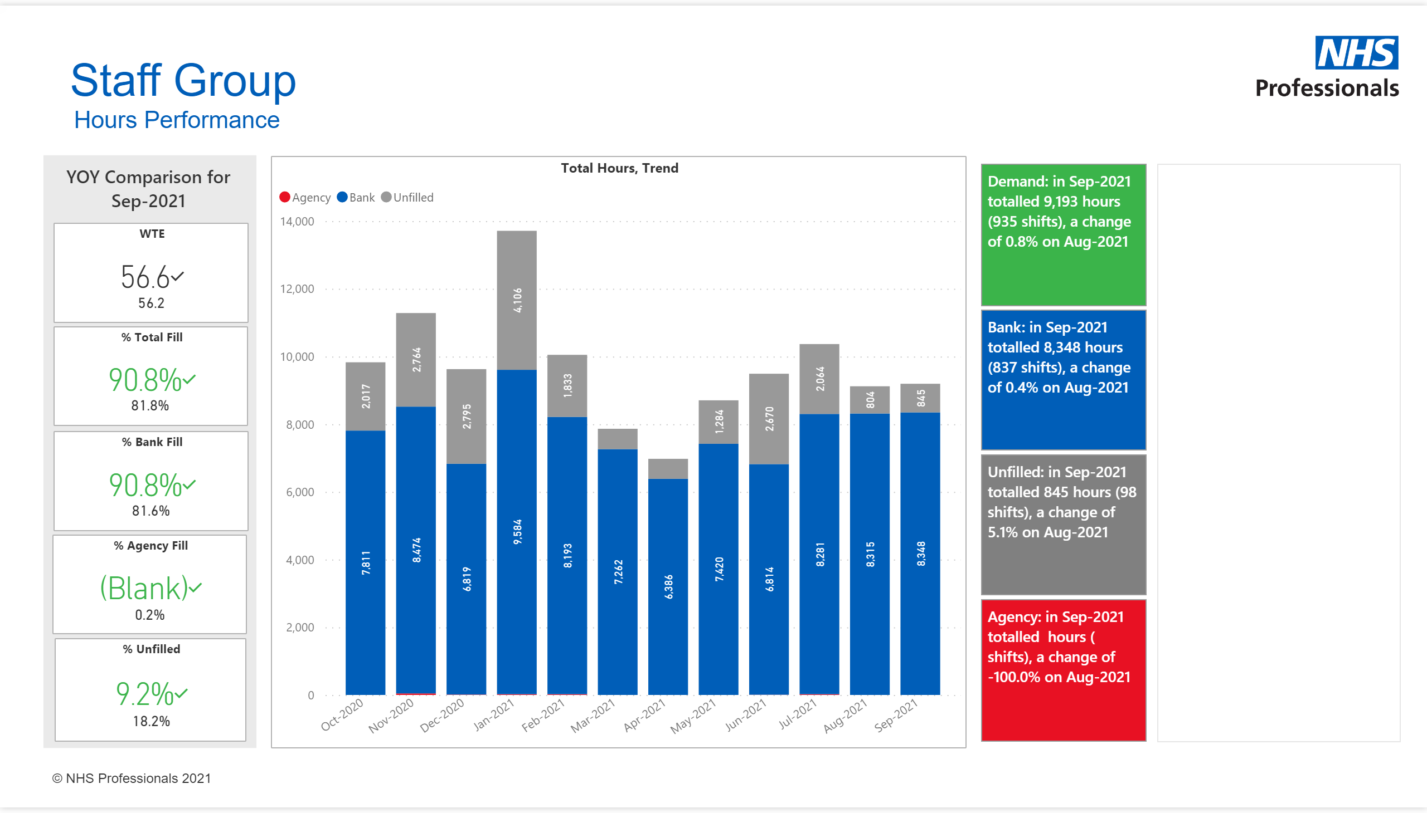](https://app.powerbi.com/groups/me/reports/cb1124a3-c197-42af-bd12-d8b64e675b61/ReportSectiond0226fa0188e6f1079e0?pbi_source=PowerPoint)

**RNs**

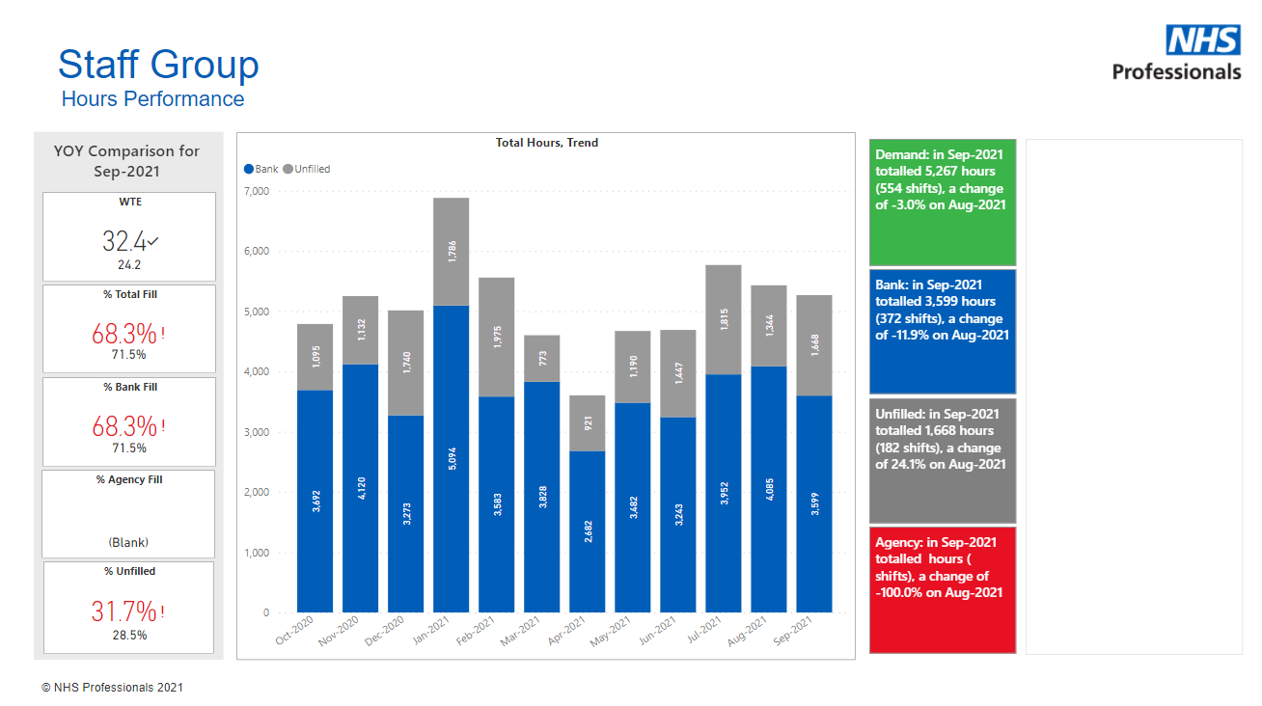

Unfilled shifts highlighted in grey are due to lack of NHSP cover and the senior nursing team do cancel requests on a daily basis following review when areas have empty beds and patients no longer requiring 1:1 supervision.

1. National Quality Board *Safe, sustainable and productive staffing* An improvement resource for adult inpatient wards in acute hospitals